# Katy’s comments, to be discussed on 7/22

Need to create table with 10+ algs that annotate CTs using one or many of

* Gene expression patterns
* Multiple B, see also Rahul’s bridge tables
* Cell morphology
* Tissue spatial info, see 2 recent ones
* Cell lineage

Also add PopV (6-28-2022 PopV version was “deprecated” but new version is at: <https://colab.research.google.com/drive/1Yw4ZDMoPgXNiC1ZQo2eS75Sw8Y_23rrb?usp=sharing>

Must make architectural drawing of complete workflow—from CxG or CODEX or other data to HRA. See Fabians example, planned WG talks in Sept. But also our

* Explain how ASCT+B and CxG relate, see Data Dictionary [https://docs.google.com/document/d/1eLJQ0xXoe-LWLobWPbfMRx-uscMxMHkgdisfNNbB0JE/edit#](https://docs.google.com/document/d/1eLJQ0xXoe-LWLobWPbfMRx-uscMxMHkgdisfNNbB0JE/edit)
* Comparing Azimuth data with ASCT+B reporter data, see <https://github.com/hubmapconsortium/asctb-azimuth-data-comparison>

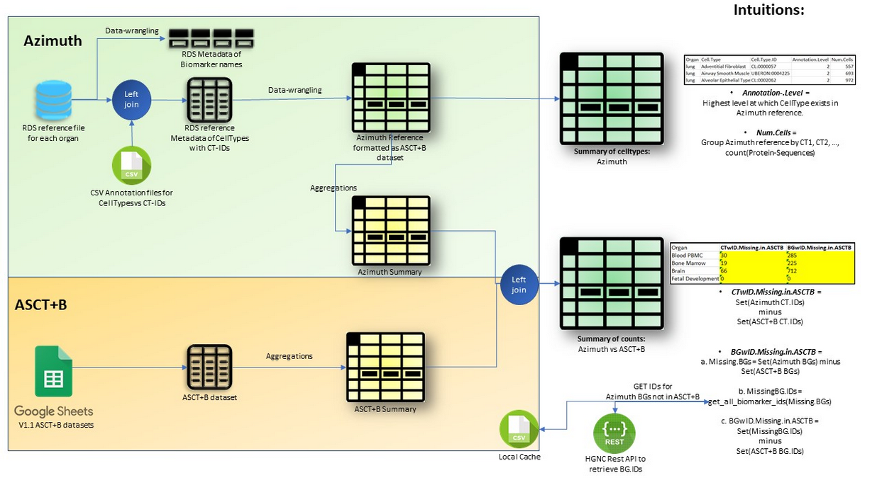

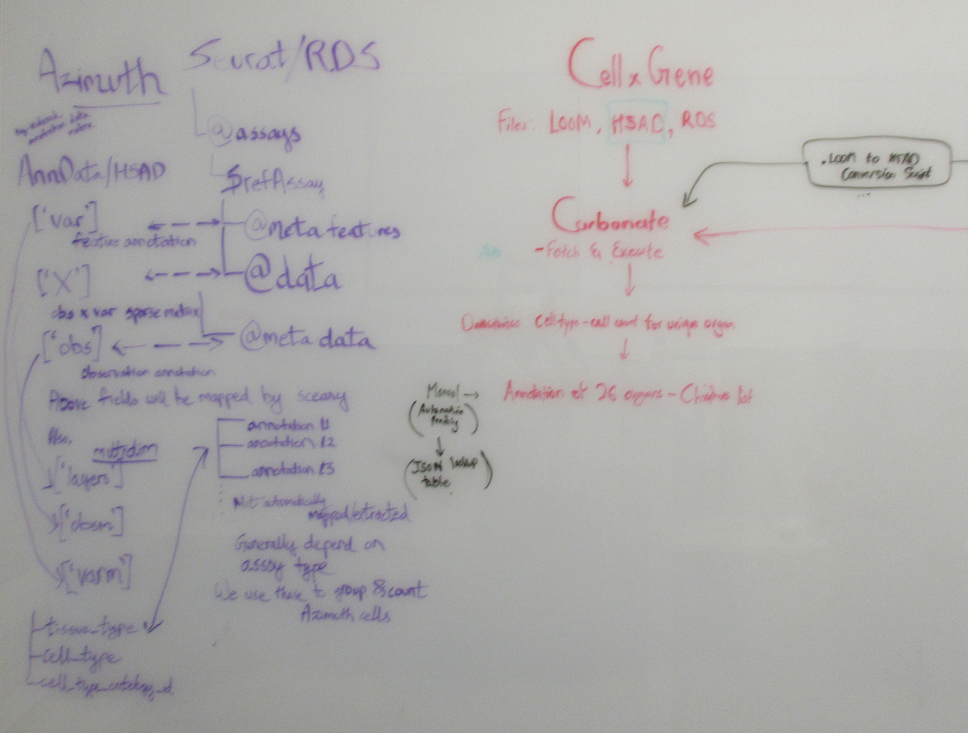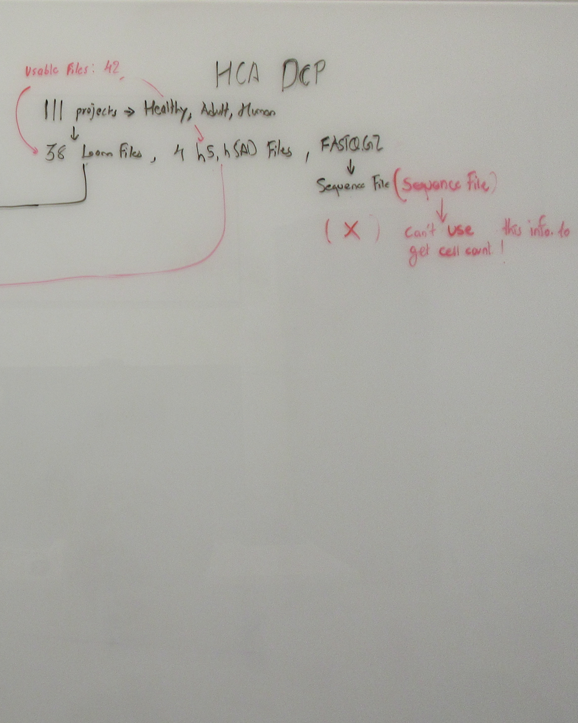 By Amber and Aashay

Identify where human expertise is needed (e.g., initial cell annotations OR cluster review using Nils’ new alg) and what alg parameters exist.

Review existing portals by HPA, GTEx, Apyter, lungmap, gutmap, etc. to see what UIs they have for CxG data. Compare with Butterfly HRA vis and FTU vis by EBI and KPMP

It should be EXTREMELY beneficial to use ASCT+B (incl. Azimuth, OMAP) data to improve CT annotation.

Need to combi segmentation and annotation, top down and bottom up analysis and meet ‘in the middle’

Let’s focus on the 20 FTUs, CT populations/patterns in those, using HuBMAP/HPA/GTEx data/KPMP. Start with K1 and K2 data. Run same alg over HuBMAP/HPA/GTEx data/KPMP data. Like Astir, use “Improbable marker-combinations CT annotation = “Other” , High probability of belonging to multiple CT annotations = “Unknown”. But for FTU specific CT populations.

Need driving use cases. I highlighted good ones in green in below. Need detailed use cases and data—with Specimen and RUI metadata. Main use case: What data gets us closer to a complete and correct HCA? (Need to run a power analysis to identify how much data on what type is needed for HRA design. For AS for which sufficient data exists, we compute “regions” that have similar CT populations yet different specimen data (sex, age) so we can capture human diversity.)

What exemplary data was used to showcase CT annotation algs? Can we RUI register this data and use it to showcase HRA?

* + - HuBMAP
    - Tabula Sapiens and others on cellxgene
    - Azimuth / CellTypist datasets

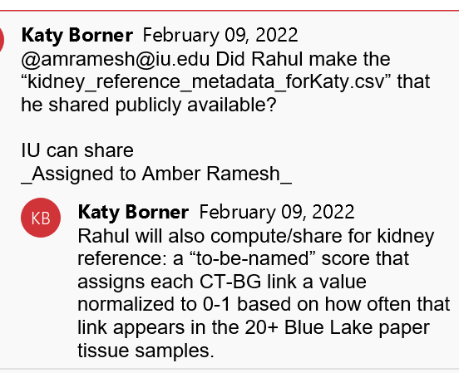

* + - Kristin Ardlie (3/25/22):
      1. The GTEx portal does host our single cell data for download (under the Datasets, Data Download tab) in scanpy h5ad format. All 8 tissues are together in the one file.
      2. Aashay downloaded h5ad file with sc data, will investigate
      3. [Dataset portal Link](https://gtexportal.org/home/datasets) [Link to Paper](https://www.biorxiv.org/content/10.1101/2021.07.19.452954v1)

We add exporting capability to the ASCT+B Reporter so CxG matrices that provide data evidence for ASCT+B nodes and edges can be downloaded in standard formats (hd5, loom, xx).

Need to compare, pick one CT x B data format

* yaml file (CT marker-gene combos)
* AnnData compatible – can read loom and h5ad files also.

Open Qs

* Must communicate prediction confidence—for CT annotations, segmentations, spatial locations, specimen info.
* What is best cross-validation? E.g., Use Fusheng AS% values and ASCT+B to get CT counts/expressions per AS.
* How to compute robustness? E.g., Add random noise to B expressions, how do UMAPs change? Which clusters/CT predictions are stable? Are l1 kidney predictions “more stable” than l2, than l3 predictions?
* How to disentangle “biomed signals/effects” from “tech/batch/patient-specific effects”? Are there ANY marker that can help identify batch problems?
* *mitochondrial genes*
* in what programming language should HRA predictions for FTY CTs be implemented? Matt R needs code that can be dockerized.
* Need FTU vis of CT x Bs
* How to add in Hickey analysis? See 4x HuBMAP and KPMP’s Kidney-Hansen



<https://www.biorxiv.org/content/10.1101/2020.07.23.216507v2.full>

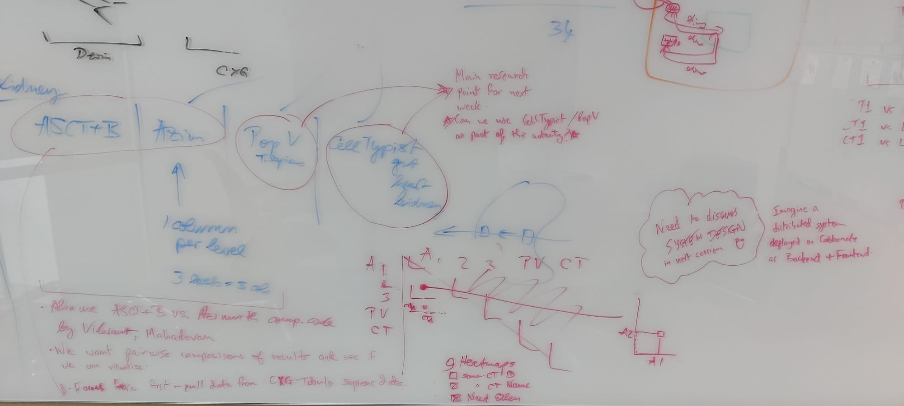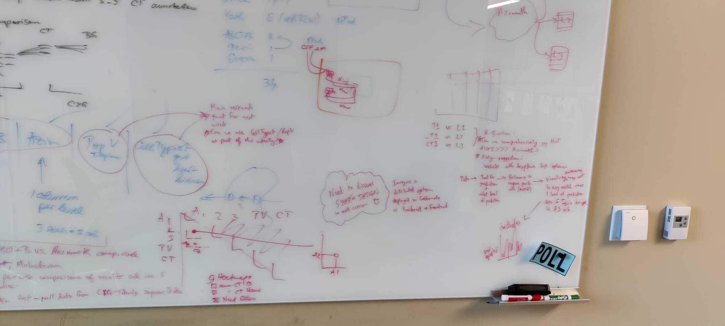

July 22nd and August 8th meeting notes: Initial draft for system design questions.

Published:

February 2021

# ASTIR

**AS**signmen**T** of single-cell p**R**oteomics

1. Cells need to be mapped to apriori known Cell-Types either by:
   1. High-Dimensional cell expressions (Phenotypes/characteristics) 🡪 Low-D Clustering 🡪 Manual cluster-annotation
   2. Weighting Low-D cell expressions on min-thresholds (like a linear combination)
2. However, 1.a. (used for HMI data) and 1. b. (used for Flow-Cytometry) requires choosing ‘k’ number of clusters, with no automated annotating, and can’t annotate unseen Cell-Types (UNKNOWN).
3. SC-RNA sequencing helps in understanding organism development, drug resistance in cancer treatment, and tumor microenvironment (cancer initiation/progression).
4. Highly-Multiplexed-Imaging (HMI) tech is better than 3., because can measure protein expressions with spatial-location of origin in tissue: Imaging-Mass-Cytometry (IMC), Multiplexed-Ion-Beam-Imaging (MIBI).
5. **Astir (ASsignmenT of single-cell pRoteomics)** can map Cell-Types faster and better than current single-cell (SC), and HMI tech.
6. Proven on 2.1 million cells collated-dataset from variety of methods.
7. Can be used for fast analysis of spatial architecture of tissue-microenvironment, automatically quantifying the immune-influx, and spatial heterogeneity in patient samples.
8. Challenges with 1.a. and 1.b. are:
   1. Prior knowledge of marker protein-expressions required
   2. Cells outside this prior knowledge won’t be marked to closest neighbours (or won’t be classified at all).
   3. Set of proteins that are measured, is experiment specific.
9. Astir is applied to 2 IMC datasets of breast-cancers:

|  |  |
| --- | --- |
| CT_annotations + spatial info = | Track phenotype changes with spatial tumor architecture |

1. Astir Input:
   1. Normalixed obs df (cell-by-gene expressions) + .yaml file (CT marker-gene combos)
   2. **AnnData compatible** – can read **loom** and **h5ad** files also.
2. Astir Assumptions:
   1. A Cell-Type expresses its marker-gene combos more than other Cell-Types
   2. Model uses continuous intensity of gene expression values
   3. Protein-Protein Covariance: marker-gene combos are correlated within a Cell-Type
   4. *Other / Unseen* Cell-Types can be identified if no marker-gene combo satisfied.
   5. Can incorporate batch/patient-specific effects (Mixed-effects model?)
3. Astir Model Workings:
   1. **Deep-recognition-neural-net with Bayesian inference**
   2. PyTorch for faster inferences and predictions on minibatches of millions of cells
   3. Post-fit diagnostics to ensure True-Positives and flag False-Positives
   4. Improbable marker-combinations CT annotation = “*Other*” , High probability of belonging to multiple CT annotations = “Unknown”.
4. Astir Demonstration on HMI and Suspension-Mass-Cytometry (SMC) breast-cancer datasets:

|  |  |  |  |
| --- | --- | --- | --- |
| **Dataset Type** | **Name(s)** | **# Patients** | **# Cells** |
| IMC | “Basel” , “Zurich” | 307 | 1.2mil |
| SMC | “Wagner” | 144 | 643k |
| IMC | “Schapiro” | 51 | 45k |
| CyCIF Multiplexed-Microscopy | “Lin” | 40 | 179k |
| **All** | **All** | *542* | *2.1mil* |

1. Astir Results:
   1. 92% of cells annotated, 8% Unknown/Other
   2. Astir compared against PhenoGraph, FlowSOM, and ClusterX. Outperforms all:
      1. Clusters evaluated based on Gene-Set enrichment analysis:
         1. Match cluster to most likely CT
         2. Derive score to quantify how well a clustering-method can identify a CT with no post-processing
         3. (score+1) if CT = 1 cluster and (score-1) if CT = unidentified/multiple clusters
         4. Score of overall method = Sum of all individual scores

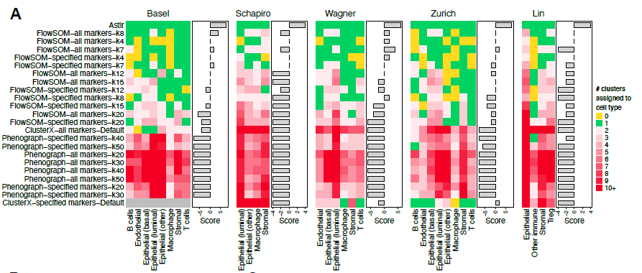

*Ideally for cell type identification, expecting all green, no yellows and few reds.  
FlowSOM: ‘k’ cluster-size, Phenograph: ‘k’ nearest-neighbors*

* + 1. Evaluate robustness of CT annotations and clusters:
       1. For different concentrations of “luminal epithelial” cells, Astir predicts most accurate ground-truth labels (top), and correctly claims one luminal-epithelial-cluster only (bottom fig.).
       2. Other tools falter here.

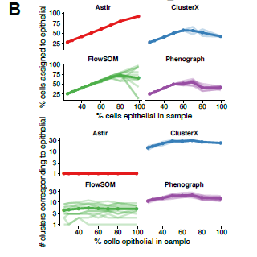

*Top: As concentration of luminal-epithelial increases, so does Astir’s prediction of these cells  
Bottom: Astir constantly correctly predicts 1 cluster of luminal-epithelial cells*

1. Astir Cell-Type implementation (**Deep Learning Bayesian inference**):
   1. First define the following $ρ, α, σ, δ, r$ as below.
   2. Define likelihood as $p\left(y | \left(z_{n}=c\right), σ, r,α, ρ, δ, β\right) \sim Normal$.
   3. Define posterior by using Dirichlet prior and minimize KL-divergence.
   4. Since KL-divergence can’t be minimized analytically, uses different initializations for ‘n’ epochs to choose best model (like Cross-validation) for a PyTorch neural-net.

|  |  |  |  |  |  |  |  |
| --- | --- | --- | --- | --- | --- | --- | --- |
| |  | | --- | |  | |  | *g=1* | *g=2* | *…* | *g=G* |  |
|  | *c=1* | 1 | 0 | … | 1 | "1" indicates this gene is a marker for this single-cell |
|  | *c=2* | 1 | 1 | … | 0 |  |
|  | *.* | . | . | . | . |  |
|  | *c=C+1* | 0 | 0 | … | 0 |  |
| |  | | --- | |  | |  |  |  |  |  |  |
|  |  | *g=1* | *g=2* | *…* | *g=G* |  |
|  | *Normalized* | 0.43 | 0.3 | … | 0.1 | Avg. value of expression across all single-cells |
|  |  |  |  |  |  |  |
| |  | | --- | |  | |  | *g=1* | *g=2* | *…* | *g=G* |  |
|  | *Normalized* | 0.2 | 0.41 | … | 0.7 | Std.Dev. value of expression across all single-cells |
|  |  |  |  |  |  |  |
| |  | | --- | |  | |  | *g=1* | *g=2* | *…* | *g=G* |  |
|  | *c=1* | 0.43 | 0.18 | … | 0.79 |  |
|  | *c=2* | 0.38 | 0.65 | … | 0.43 | Expression level observed for this gene in this single-cell |
|  | *.* | . | . | . | . |  |
|  | *c=C+1* | 0.35 | 0.33 | … | 0.84 |  |
|  |  |  |  |  |  |  |
| |  | | --- | |  | |  | *g=1* | *g=2* | *…* | *g=G* |  |
|  | *c=ct1* | 0.5 | 0.5 | … | 0.5 | CT-specific gene-gene correlation matrix |
|  | *c=ct2* | 0.5 | 0.5 | … | 0.5 |  |
|  | *.* | . | . | . | . |  |
|  | *c=ctC+1* | 0.5 | 0.5 | … | 0.5 |  |

Published:

February 2018

# ScanPy

Scalable **S**ingle-**C**ell **AN**alysis using **Py**thon

1. Created because in 2018, the following tools couldn’t scale up to millions of input cells: Seurat, Monocle, Mast, CellRanger, SCDE/Pagoda, etc.
2. ScanPy provides Python interface to link up with Tensorflow/PyTorch.
3. AnnData compatible (ScanPy authors created AnnData!).
4. Functionalities:
   1. Preprocessing (similar to Seurat)
   2. T-SNE visualizations
   3. Graph drawing, diffusion maps
   4. Clustering using Louvain algorithm (similar to Phenograph)
   5. Identifying marker genes for clusters via diff-expression tests (similar to Monocle).
5. Scanpy vs Seurat benchmarking done in 2018 (PBMC data):
   1. Scanpy is 5 to 90 times faster in all preprocesssing steps to CT-identification
6. Scanpy vs Cell-Ranger benchmarking in 2018 (PBMC data):
   1. Scanpy is 5 to 6 times faster in all preprocesssing steps to CT-identification
7. 1.3 million cells analyzed using Scanpy in few hours

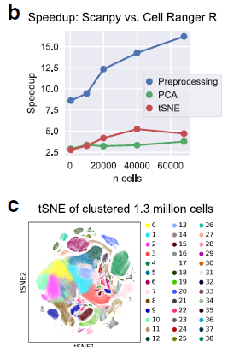

*Above: Performance benefits of ScanPy as compared to CellRanger*

*Below: Brain cells from E18 mice, public data 10x Genomics*

1. **ScanPy-pipeline for single-cell RNAseq data analyses:** [Tutorial](https://training.galaxyproject.org/training-material/topics/transcriptomics/tutorials/scrna-scanpy-pbmc3k/tutorial.html)

* Cellranger conventionally creates 3 files to represent the huge but sparse matrix:

*genes.tsv, barcodes.tsv, matrix.mtx*

* Convenient to store, but not to process. Hence AnnData.
* AnnData stores count-matrix **X,** with annotations of observations (i.e. cells) **obs**, variables (i.e. genes) **var** and unstructured annotations **uns.**
  1. **Preprocessing**:
     1. Quality control:
        1. Remove *genes that appear in small # of cells* (probably noise).
        2. Remove *low-quality cells that have small total counts, and small # of genes expressed* (likely noise).
        3. Remove *cells mapped to high amount of mitochondrial genes* (requires custom data processing- Add new column and aggregate).
     2. Scaling normalization:
        1. Counts for each cell are divided by a cell-specific scaling factor, often called a “cell size factor” to remove technical biases.
     3. Feature selection:
        1. Genes highly expressed in some cells, and lowly expressed in others.
        2. These "interesting" genes will be effective in clustering after dimensionality-reduction.
     4. Scaling the data:
        1. Before dimensionality-reduction, scale data to mean=0, variance=1.
  2. **Dimensionality reduction:**
     1. Principal Component Analysis:
        1. Project info from multiple dimensions (genes) onto "eigengene"s.
        2. ScanPy performs PCA on log transformed (cell x gene) expression matrix
        3. Performed on log-transformed scaled data to identify lower-dimensional axes that capture largest amount of variation,
     2. Determination of the number of PCs to keep:
        1. Use “Elbow plot” for visualization of expression profiles: a ranking of the PCs based on the percentage of variance they explain.
  3. **Clustering of the cells:**
     1. Build neighborhood graph:
        1. Nodes: Single cells
        2. Weighted edges: connections between cells having similar expression-profiles
     2. Visualize the neighborhood graph:
        1. Non-linear dim-reduction to learn underlying manifold of data.
        2. UMAP (ScanPy authors recommend- better preserves trajectories)
        3. t-SNE
     3. Clustering the graph:
        1. Partition the graph into clusters of highly interconnected cells by defining 'granularity' of clustering (0.4 to 1.2 normally)
        2. Louvain algorithm recommended
        3. SLM algorithm
        4. Leiden algorithm
  4. **Finding marker genes** **to distinguish each cluster:**
     1. Differential expression between clusters.
     2. These marker-genes are then used to functionally annotate clusters with "cell-type" names.
     3. Use statistical tests to quantify differences in expression-profiles: t-test, Wilcoxon rank sum test.
     4. Visualize expression of marker genes look at the distribution of the expression of each marker gene in cells for each cluster
     5. Comparison of the marker genes between clusters:

  
*Heatmap of expressions by marker-genes (32k cols) in cell-clusters (2.7k rows)*

* 1. **Cell type annotation:**
     1. We can use canonical marker-genes for known cell-types.



*Clusters are annotated with cell-types using known canonical marker-genes*

Published:

January 2022

# scDIOR

**s**ingle-**c**ell RNA-seq **D**ata **I**nput-**O**utput softwa**R**e

1. R and Python main platforms for analyzing single-cell data.
2. scDIOR developed by considering the data formats of:
   1. Seurat (RDS)
   2. ScanPy (AnnData)
   3. SingleCellExperiment
   4. Monocle
3. Made specifically to compare performance of these 4 different tools.
4. Uses HDF5 (.h5 file format) as data management, storage software suite (v fast, efficient). .h5 can be read in both platforms
5. Seurat & Scanpy are meant to handle both the scRNA-seq and spatial transcriptomics data. We can perform interconversions between `.rds` <-> `.h5` <-> `.h5ad`.
6. Evaluated performance using Cao2019 Dataset (Mouse organogenesis data: embryo germ cells transform into internal and external organs):
   1. 2 million cells
   2. 26k genes

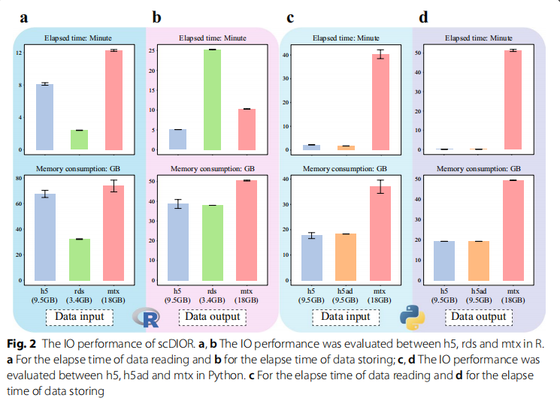

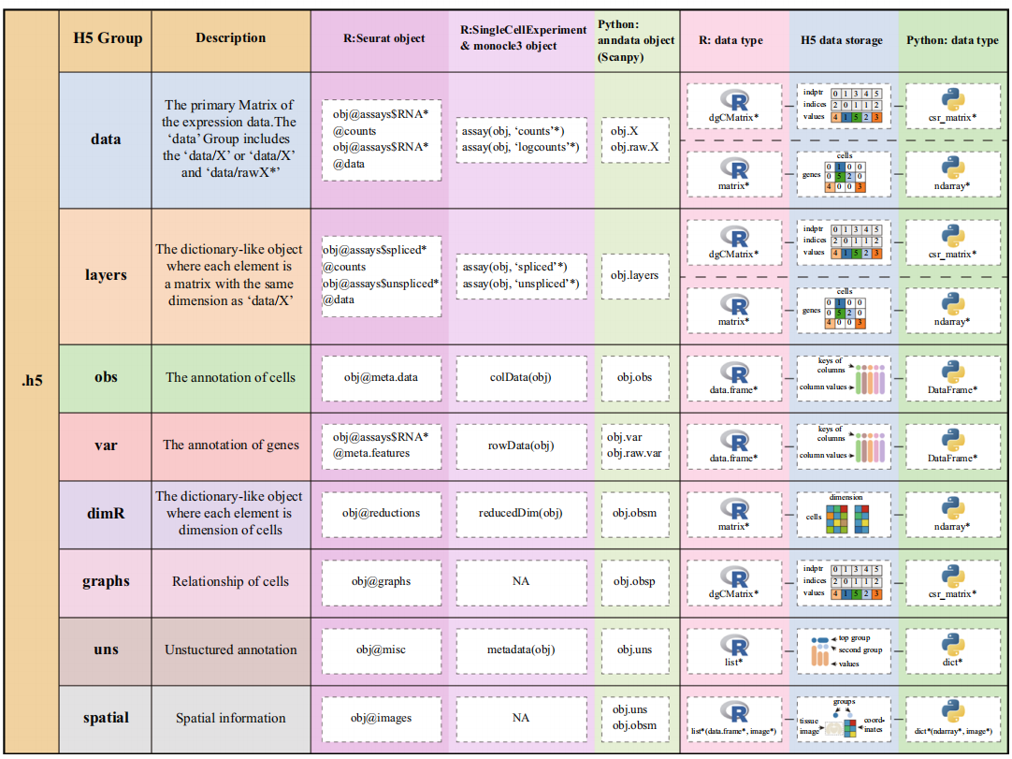

* *.h5 file format has groups which allow interchangeable conversion between AnnData <-> RDS*
* *scDIOR implemented the unification of sparse matrices between Compressed Sparse Column (CSC) format (****R: Matrix dgCMatrix****) and Compressed Sparse Row (CSR) format (****Python: SciPy scipy.sparse.csr.csr_matrix****)*

Published:

May 2022

# CellTypist

1. CellTypist is an interpretable pan-tissue database and automated tool for cell type annotation, focused on immune cells for now.
2. There are few tools as we’ve seen above that:
   1. Foster all features needed to categorize a CT
   2. Can categorize CT as UNKNOWN if not in train-data
   3. Distinguish highly homogenous cell populations
   4. Integrate into existing popular analysis workflows
   5. Are scalable to large datasets
3. To predict CT's on test-data, Usually tools use reference-datasets from publications which contain CT's. Hence, comprehensiveness is not guaranteed.
4. CellTypist is currently focused on immune cells. Immune cells shared across tissues. Hence authors built a reference-DB of {*cross-dataset*}+{*cross-tissue*} Cell-Types (liver Kupffer cells, placenta Hofbauer cells, kidney-resident macrophages, monocytes).
5. Despite heterogeneity in immune cells caused by their {*ubiquitous nature*}+{*adaptations to local envs*}+{*developmental lineage dynamics*}. they can be grouped into CTs based on:
   1. marker gene-expressions profiles
   2. functional roles
   3. parent lineages.
6. CellTypist prediction is **One-vs-all Logistic Regression with Stochastic Gradient Descent Optimization**:
   1. **Low-Resolution** (higher hierarchy): Coarse granularity (not so detailed 32 CT annotations)
   2. **High-Resolution** (lower hierarchy): Fine granularity (very detailed 91 CT annotations possible)
7. **Dataset compilation and integration:**
   1. Organ agnostic Cell-Type prediction would need a cross-tissue immune cell reference DB as the training-set.

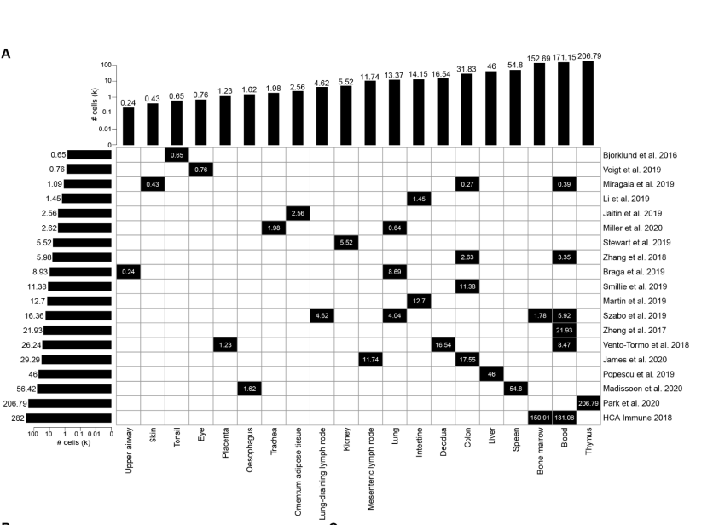

*Heatmap showing # of cells for* ***19******datasets*** *(row) vs* ***20 tissues*** *(column)*

* 1. Model’s immune-cell training data = expression-matrix WHERE CELL EXPRESSES (GENE==’PTPRC’)
  2. For datasets with already annotated cells, filter WHERE ANNOTATION LIKE ‘%IMMUNE%’
  3. To view the combined immune-cell atlas:
     1. input gene-expression count matrix + covariate keys {"Dataset","Protocol"} 🡪 scVI model 🡪 latent_vars 🡪 scanpy.neighbourhood_graph 🡪 scanpy.UMAP representation

1. **Cell-Type label harmonization:**
   1. Relatively small amount of comprehensive training-data available:

n(Train) < 1mil and n(ImmuneCell_Train) < 500k.

* 1. Hence, not advisable to use data-driven CT annotation for cells with very similar transcriptomes like T-cells. Thus, CellTypist has 2 prediction hierarchy-levels as described in #6 above.
  2. Restricting to fewer, but high-quality and high-confidence hierarchies is the goal.
  3. Label harmonization pipeline for homogenizing CT annotations of training-data, and then use these harmonized labels to train the actual 2-hierarchy CellTypist models:

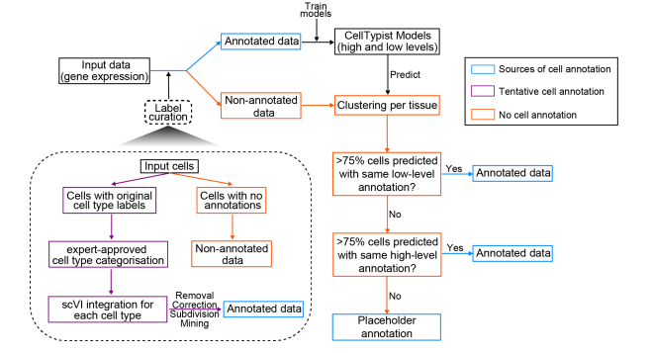***Annotated-Cells*** *are curated via Removal, Correction, Subdivision, Mining****Non-Annotated-Cells*** *are clustered and assigned labels by majority voting*

* 1. More details on the Annotated-Cells label harmonization pipeline:
     1. REMOVE the cells that were mis-annotated in original publications:

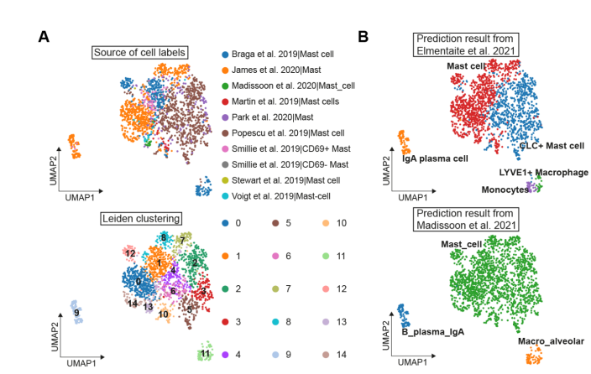

***Left****: Clusters #9, #11 are predicted as “Mast Cells” for combined 10 train-datasets of “Mast Cells”.****Right****: 2 individual train-datasets predict Clusters #9, #11 as “Plasma”, ”Monocytes”. Hence REMOVE them.*

* + 1. CORRECT the cells that were mis-annotated due to their similar transcriptomes:

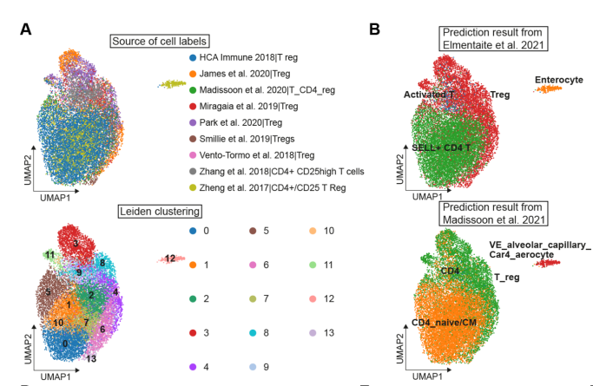

***Left****: Clusters #(0,1,2,5,7,10) are predicted as “Mast Cells” for combined 9 train-datasets of “T Cells”.****Right****: 2 individual train-datasets predict Clusters as “naïve central memory CD4 T Cells” Hence CORRECT them.*

* + 1. SUBDIVIDE some broad CTs into clear and fine-granularity CTs at a lower hierarchy.
    2. IDENTIFY/MINE for CTs that went unnoticed in original publication.

1. **Propagating annotations to non-annotated cells:**
   1. Even after the 4 label-harmonization steps mentioned in #8 above, there will be Cells with no annotation.
   2. Next, cluster using Scanpy pipeline 🡪 infer CT prediction from CellTypist trained model 🡪
      1. Cluster with >75% cells matched low-hierarchy (fine granularity) CT annotation:

Assign low-hierarchy CT annotation + high-level (coarse granularity) CT annotation.

* + 1. Cluster with <=75% cells matched low-hierarchy (fine granularity) CT annotation:

Assign only the high level (coarse granularity) CT annotation.

1. **Model Training:**
   1. Logistic Regression framework with L2 penalty, and we use minibatches of 1000 cells sampled, instead of entire training data.
   2. Model training done for 30 epochs with such 100 independent minibatches in each.
   3. Cell-Types can be configured to be balanced within each minibatch (rare CTs to occur in equal proportion as the rest of CTs).
   4. But authors already prove performance accuracy would be equivalent to randomly sampled minibatches.
   5. Stochastic Gradient Descent allows for online learning and quick updates to CellTypist models.
   6. Feature selection is also done after initial CellTypist model training: choose top 300 genes for each CT by ranking the genes by their weights in the CT. These filtered few genes will help reduce complexity of the final trained models.
2. **Processing of train-test datasets:**
   1. For CellTypist model training, input datasets normalized to 10k counts per cell and log-transformed.
   2. Expression of each gene (column) in input gene matrix is scaled to mean=0, sd=1.
   3. The original mean and sd recorded from train-dataset is used to transform the expression of genes (columns) in test-dataset.
   4. CellTypist also uses automatic feature-selection (genes) to reduce the # of informative marker genes required for CT-annotation.
   5. Why gene-expression matrix was normalized and scaled, rather than batch-corrected:
      1. Genes expressing different levels across different batches, can be penalized equally using the L2 regularization on Logistic Regression classifiers.
      2. SGD converges faster and better using these scaled/transformed values.
      3. Normalization and scaling can be done quickly on test-dataset since we record the mean and sd of each gene’s expression level in the train-dataset.
      4. Predictions after normalization+scaling are better and faster than Predictions after batch-correction.
3. **Cell-Type prediction process:**
   1. Predicting a test-data Cell is a CT:
      1. score = linear combo of: {scaled gene expression} + {model-coefficient for that CT}
      2. probability = sigmoid(score)
   2. Why "multiple independent binary classifiers of logistic-regression framework" rather than "multinomial logistic-regression":
      1. Raw scores are kept aside for potentially investigating controversial predictions.
      2. Multinomial logistic regression would give only probabilities.
   3. 2 modes of CellTypist predictions:
      1. mode="best match" : Assign most likely CT to given test-data Cell
      2. mode="prob match" : Assign 0 or more CT(s) to given test-data Cell.
4. **Overclustering and majority voting:**
   1. Cell-Type prediction in #12 is for individual cells. Majority voting will combine these, assuming that transcriptomically similar Cells will form subclusters.
   2. Scanpy will be used for neighborhood graph creation and then clustering (Leiden algorithm).
   3. Individual CT predictions 🡪 Neighbourhood graph 🡪 Leiden clustering 🡪 Majority voting to determine CT for easily distinguishable clusters 🡪 <70% CT population clusters are called "Heterogenous".
   4. If subcluster=="Heterogenous", can inspect individual CT predictions and overall high-level majority votes.

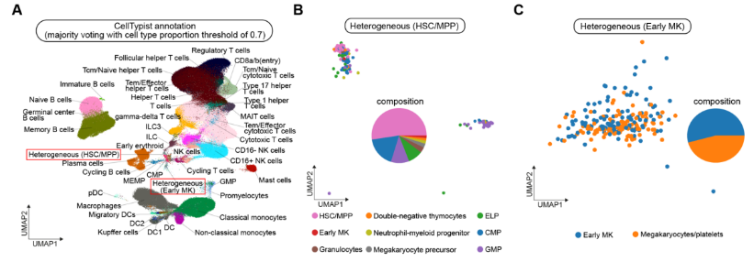  
*Heterogeneous cell clusters using CellTypist can be investigated further.*

1. **Benchmarking ‘CellTypist’ vs ‘Logistic Regression’, ‘SVM’, ‘Azimuth’, ‘scNym’:**
   1. To understand the effect of training-dataset size on CellTypist’s prediction accuracy:
      1. Test-dataset = 10k cells sampled from the comprehensive Immune Cell reference DB
      2. Train-datasets = 5k, 50k, 250k cells sampled from same DB
   2. Unbiased comparisons for:
      1. CellTypist, Logistic Regression, Support Vector Machines:
         1. Normalize and log-transform gene-expression matrix of training-data,
         2. Use mean and sd of training-data to transform test-data.
      2. scNym:
         1. Train-data and test-datasets were normalized to 1mil counts per cell, and then log-transformed.
      3. Azimuth:
         1. Train-data and test-datasets were normalized to 10k counts per cell, and then log-transformed.

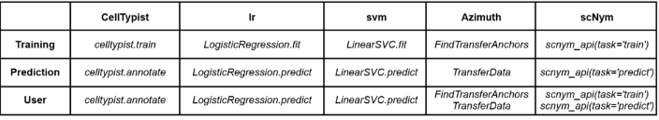

*“User time” is time required for user to receive predictions after supplying input*

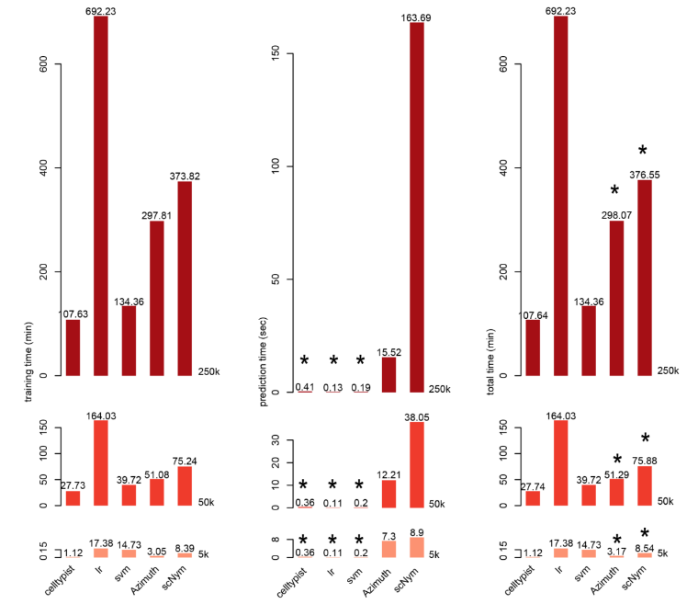

***Left***: Training time in minutes for dataset sizes (5k, 50k and 250k)- CellTypist is fastest  
***Center***: Prediction time in seconds for dataset sizes (5k, 50k and 250k)- SVM/LR/CellTypist are fastest  
***Right***: Total time taken in minutes for dataset sizes (5k, 50k and 250k)- CellTypist is fastest  
“User time” is marked with $⋆$ ***Takeaway*:** CellTypist outperforms Azimuth in all cases.

1. **Cell-Typist performance on the overall reference atlas:**
   1. Train-dataset 90% of Atlas, and Test-dataset 10% of Atlas:
      1. High-hierarchy CellTypist model = 0.97 precision, 0.88 recall = 0.95 F1-score
      2. Low-hierarchy CellTypist model = 0.91 precision, 0.84 recall = 0.89 F1-score

Published:

Sep 2021

# OnClass

**On**tology based **Class**ification

1. Onclass can classify cells to any cell type as long as its corresponding term is captured in the Cell Ontology, even if the Cell-Type is absent in train-dataset.
2. OnClass can Identify marker genes for all the cell ontology categories, regardless of whether the cell types are present or absent in the train-dataset.
3. Joint analysis of datasets generated by independent labs, remains challenging due to a lack of consistent terminology to describe cell types.
4. Cell Ontology is proposed as a basis for consistently annotating large-scale single-cell atlases.
5. 95% of cell types in the Cell Ontology are unseen even in the largest datasets. Hence Atlas construction which ambitiously encompasses more CTs that give holistic view of organ/tissue via the comprehensive CxG matrix.
6. Some terminology in this paper:
   1. **unseen Cell Ontology terms** = CTs in Cell Ontology that don't exist in Train Data
   2. **seen Cell Ontology terms** = CTs in Cell Ontology that exist in Train Data
7. OnClass uses both the Cell Ontology graph and the cell type description to classify single cells:
   1. **step 1**: NLP for translating raw-label --> Cell Ontology label

*Most Relevant For Our Use-Case?*

* 1. **step 2**: Project the following onto low-dimensional space:
     1. cell-types via Cell Ontology graph.
     2. annotated cells to region of cell-type via the sc-transcriptomes.
  2. **step 3**: Refine each cell-annotation by overlaying confidence scores on Cell Ontology graph.

*Similar to K-Nearest neighbors, or Majority Voting in local subclusters?*

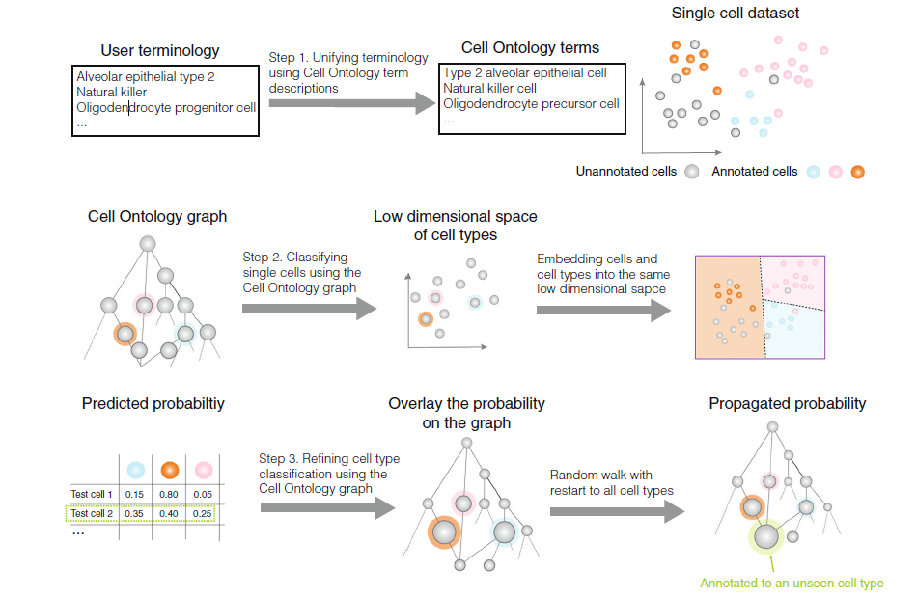

1. Evaluation done by comparing three types of cell type similarities:
   1. Cell Ontology graph-based similarity (cosine similarity between the random walk with restart distributions),
   2. Cell-type text description-based similarity (cosine similarity between low dimensional text representations of cell type description), and
   3. Gene expression-based similarity

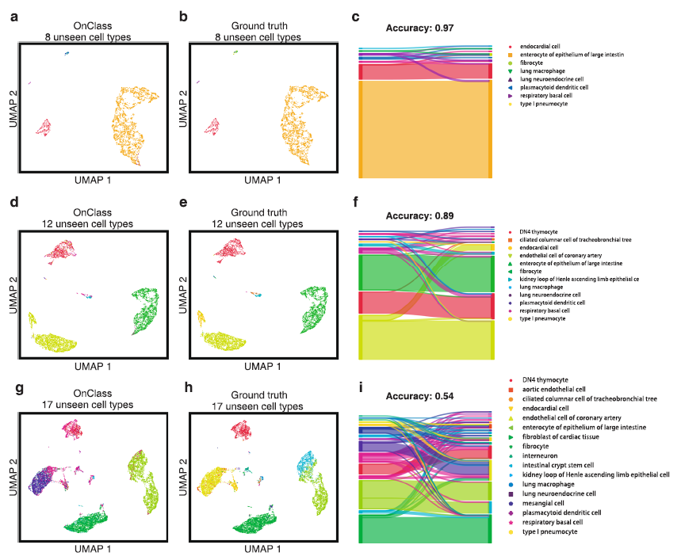  
***(Right column) Sankey diagram*** *connects node1 to node2 with certain thickness. The thickness goes on reducing if there's branching-out from node1 to node2, node3, node4, ...*

*Hence in fig.f. above, "type I pneumocyte" thickness is huge at the beginning (node1=predicted labels), but reduces as we move to right (node2, node3, node3... =expected labels). We observe branching out.*

* While trying to come up with a translation file for PopV raw-labels à standardized labels, I came across [OnClass](https://www.nature.com/articles/s41467-021-25725-x) (Ontology based Classification).
* Step 1 above, of the paper’s implementation uses a pre-trained BERT model (NLP Deep Learning) to translate input text (raw-labels), into standardized Cell-Ontology labels, by comparing cosine-similarities of the encodings.

I.e.- the author captured NLP encodings for each of 2331 CT-IDs on Cell-Ontology in 768 dimensions. The input-text encoding is then compared against these 2331 encodings, and the best CT-ID is pulled out.

Managed to reverse engineer the OnClass [code](https://onclass.readthedocs.io/en/latest/) (a few dependency and code errors again), and completed a proof-of-concept.

* Mostly, we seem to have correct translations from raw à standardized labels.

Ex- An Input “*nk cell*” gets mapped to the standardized Cell Ontology CT-ID for “*natural killer cell*”.

Similarly, “*pericyte cell*” gets mapped to the Cell Ontology CT-ID for “*pericyte*”.

* However, there are some False Positives.

Ex- An Input “*cd4-positive alpha-beta t cell*” gets mapped to “*T-helper 22 cell*”, while an Input “*cd4-positive, alpha-beta t cell*” gets mapped to the correct “*CD4-positive, alpha-beta T cell*”.

Note that there’s only a comma added in the second input.

* These False Positives are likely because the BERT model used, produces poor embedding quality:

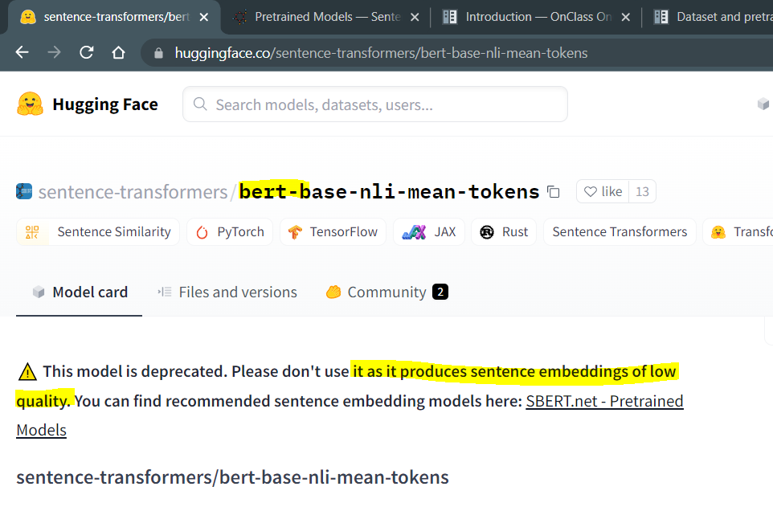

* There’s also some False Negatives.

Input “*capillary aerocyte*” not matched at all against the Cell Ontology label-embeddings. Certainly, require SME input to get mapped to a correct CT-ID rather than a Blank.

* These may be because:

1. The input naming-convention is just altogether different leading to a very poor encoding, or
2. The fact that Cell-Ontology gets constantly updated with new CT-IDs and labels, which the author hasn’t updated (the Cell-Ontology export files aren’t updated since 2021 June, and there may be >2331 CT-IDs by now).

Possible to-do list if this seems interesting:

* Update author’s code for better documentation and error handling.
* Fixing False Positives :

1. Update the BERT model to a better model available on [Hugging Face](https://www.sbert.net/docs/pretrained_models.html). May require supervised-training phase.

* Fixing False Negatives :

1. Re-implement author’s ML training phase with entire Cell Ontology export as input, and generate new embeddings, or
2. Use Souradeep/Bruce’s code that does explicit string-similarity checks for mapping input raw-label to most similar standardized-label.

Published:

Jun 2020

# FR-Match

**Friedman-Raphsky based Cluster Matching**

1. **Main purpose for FR-match creation:**

*Cell-Type matching problem* - Check if queryCluster and refCluster got from 2 similar but independent experiments are same.

1. FR-Match could be used for OBJECTIVE ASSESSMENT of CT-cluster-annotations between 2 datasets (somewhat like ***Single Cell Data Evaluation***).

Applicable to cross-platform, cross-specimen, cross-anatomy and cross species matching of scRNAseq clustered data.

1. **Input to FR-Match**:
   1. CxG matrix for query and ref datasets.
   2. Canonical-Annotations/Simple Cluster Allocation for query and ref datasets.
2. **Output from FR-Match**:
   1. p-Values for evidence that query and ref data cluster are matched in multivariate space.
3. **Steps in algorithm**:
   1. *Feature Selection*: Select informative marker genes for the input refCluster (ex- NSForest). Create subsample matrices of refCluster cells and queryCluster cells, with only common informative-genes expressed.
   2. Create connected-graph for all cells within queryCluster and refCluster in the lower dimensional space of informative genes.
   3. Construct MST for this connected-graph by considering edge-weights in this Euclidean lower-dimensional space of informative genes.
   4. Edges that connect cells of different clusters are then removed and the number of disjoint subtrees is counted (R is ‘multivariate runs’).
   5. Calculate the FR-statistic using graph theory estimates of E[R] and Var[R]:

  
$$W=\frac{\left(R-E\left[R\right]\right)}{\sqrt{Var\left[R\right]}}$$

*Top row*: Choose subsampled matrices of queryCluster and refCluster, retrieve informative genes from NSForest or something similar, and filter on only common informative genes.  
*Bottom row*: 3 common informative genes in queryCluster and refCluster visualized, graph theory applied to derive the FR-statistic.

1. **Main idea behind FR-match Minimum-Spanning-Tree trimming:**

***R*** is large in 5.d. or if ***W*** is large in 5.e. =>

the pooled cells were closely interspersed =>

multivariate gene-expression distribution (refCluster) == distribution (queryCluster)

1. **The Friedman-Raphsky hypothesis test**:
   1. Multivariate generalization of the non-parametric two-sample comparison problem.
   2. Assume,

RefCluster (*Fx*) has *m*-cells containing *k*-genes expressed.

QueryCluster (*Fy*) has *n*-cells containing *k*-genes expressed.

*___k* => number of informative marker genes from the refCluster.

* 1. **H_0**: Distribution(refCluster) == Distribution(queryCluster)
  2. **H_1**: The 2 multivariate-distributions are different.

Published:

Jul 2021

# NS-Forest

**N**ecessary and **S**ufficient Random **Forest**

1. **Input**:
   1. CxG matrix for dataset.
   2. Canonical-Annotations/Simple Cluster Allocation for dataset.
2. **Output**:
   1. Necessary and sufficient marker genes for each CT-cluster.
   2. Minimum set of marker genes for CT-cluster (usually 1–4), whose expression-combo is sufficient to discriminate the target cell type cluster from the rest of the cells.
3. **Steps in algorithm**:
   1. Feature selection:

Build random forest model, with 10,000 decision trees each, for the CxG matrix with CT-annotations under a binary classification scheme.

Rank the genes according to avg. information gain (based on Gini Index in the Random Forest).

* 1. Feature ranking:

For the top 15 ranked genes above, compute:

$$Binary score for gene {'g}^{'} in cluster {'k}^{'}=>$$

$$Score_{g,k}=\frac{{\sum_{k^{'}=1}^{K}{\left(1-\frac{median_{g,k^{'}}}{median_{g,k}}\right)}}^{+}}{K-1}$$

$Score_{g,k}=1$ means ‘g’ is excellent for discriminating cluster ‘k’ from all other clusters.

* 1. Minimum feature determination:

Find F-beta score for all combinations of Top 6 binary-genes.

$$F_{β}=\left(1+β^{2}\right)\frac{precision*recall}{β^{2}*precision+recall}$$

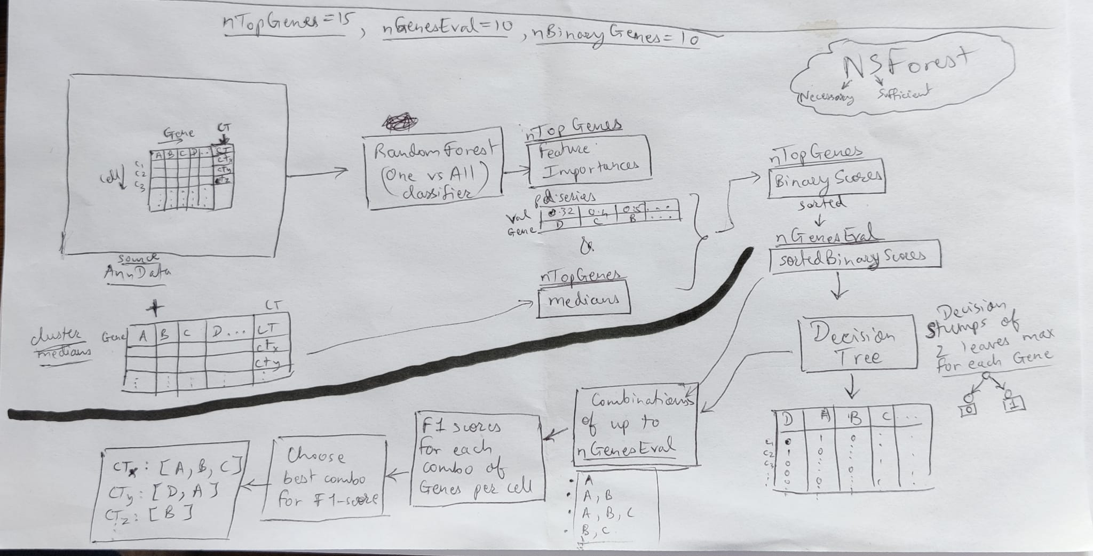  
Entire code/algorithm flow in latest NSForest unpublished repo

Published:

May 2022

Reference-based cell type matching of spatial transcriptomics data

* Mouse Primary Visual Cortex tissue was processed using:
  + 4 spatial transcriptomics techs: output is spot-by-gene matrix per image pixel.
  + Baysor segmentation algorithm converts spot-by-gene into cell-by-gene, and filters out low-quality cells.
  + 6 CT matching algorithms (not algorithms that make predictions on query dataset)
* Main goal was scRNA-seq-reference-based CT assignment on spatial transcriptomics data.

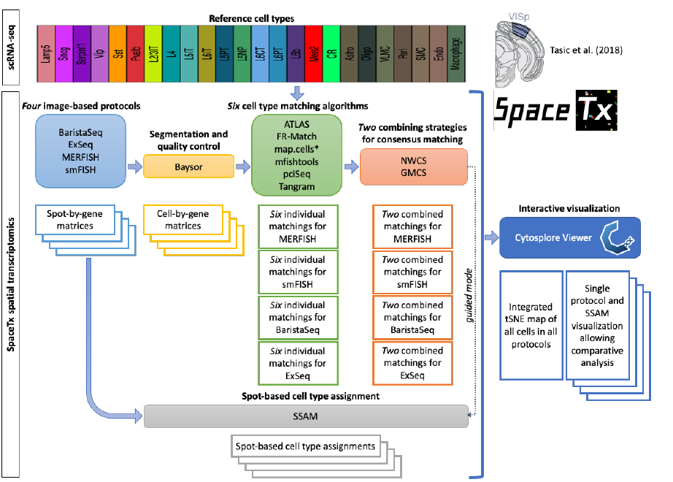

* Baysor cell-segmentation algorithm outputs a CxG count matrix for all 4 imaging-protocols (below table).

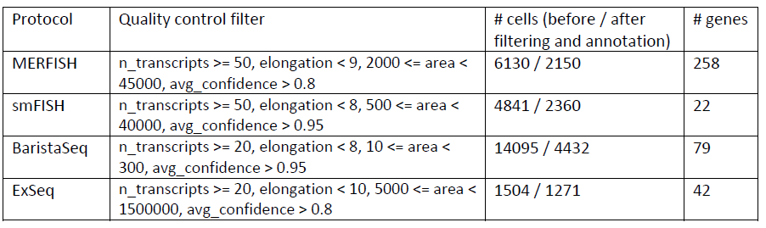

* Meta-analysis scoring strategies to arrive at a consensus CT assignment from the 6 scRNA-seq algorithms:
  + Geometric Mean Combining Strategy (GMCS)
    - Figure below
  + Negative Weighting Combining Strategy (NWCS):
    - Find the best-matched cell types of each cell (highest confidence score).
    - Make all other weights negative (-1*wt).
    - Sum up all negatively weighted confidence scores for each individual method.
    - The consensus-assignment is the CT with the max confidence score for each cell in the combined matrix.

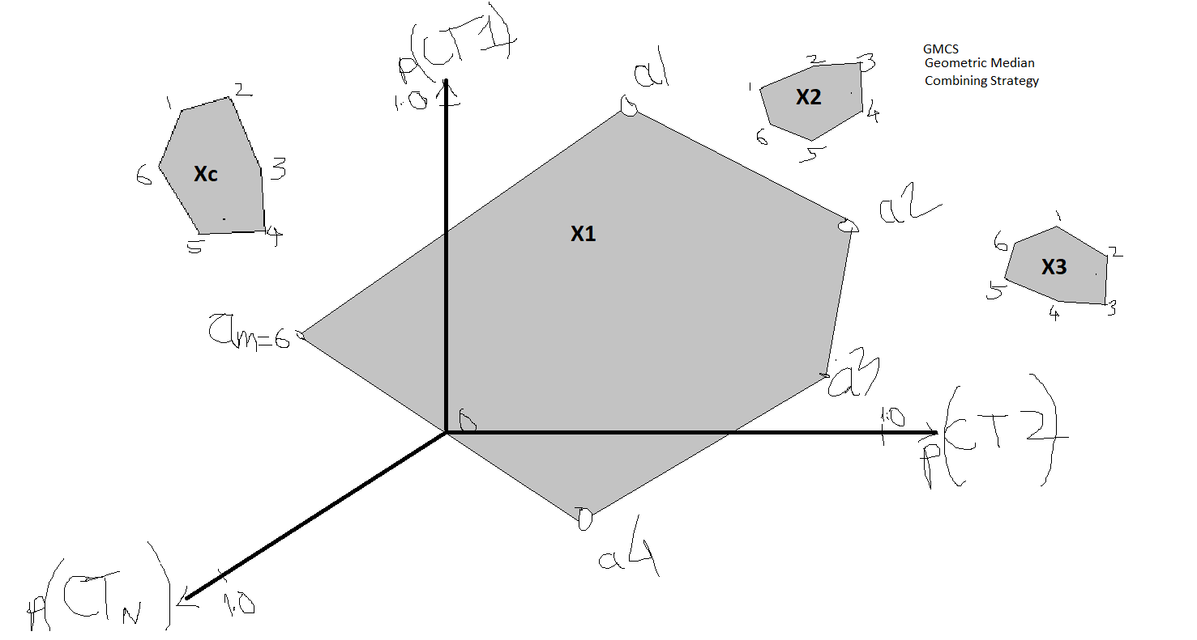

* Confidence-like Scoring metrics are inherently different across the 6 algorithms (A): p-values, correlation score, accuracy, etc. Hence, logical to use ranked scores to produce consensus Cell-Type assignment.
* Amount of Cell-Type disagreement between different modalities (D) - Generalized Venn/Euler Diagram here, but an UpSet plot would be more readable: link.
* The 2 consensus algorithms applied show inter-agreeability (E).

